Project report on

WhatsApp-Based Home Automation Using Raspberry Pi

Submitted by

Dhruv Mohapatra (2341013364) Akash Kumar Panda (2341016041) Ansuman Sahu (2341019234)

B. Tech. (CSE(IOT) 4th Semester (Section–23412B1)



CENTRE FOR INTERNET OF THINGS DEPARTMENT OF COMPUTER SCIENCE AND ENGINEERING
Institute of Technical Education and Research

SIKSHA ‘O’ ANUSANDHAN
DEEMED TO BE UNIVERSITY
Bhubaneswar, Odisha, India. (May 2025)

i

Abstract
This project focuses on implementing a low-cost and user-friendly home automation system using WhatsApp and a Raspberry Pi Zero 2 W. The aim is to allow users to control basic appliances such as a fan and an LED light simply by sending messages over WhatsApp. The system integrates the Twilio API, which receives these messages and passes them to a local Flask server running on the Raspberry Pi. The server interprets the messages and activates or deactivates the corresponding GPIO pins to control the hardware. This eliminates the need for a custom mobile application and leverages an interface—WhatsApp—that users already know well. By using a lightweight and affordable hardware setup, this system makes IoT-based automation more accessible for everyday use, particularly in homes, educational environments, and small-scale applications.
This system demonstrates practical integration between cloud communication (Twilio), local web services (Flask), and hardware control (Raspberry Pi GPIO). It is scalable, adaptable, and provides a foundation for more advanced automation systems. It empowers users to manage appliances remotely with minimal technical setup, promoting ease of use, especially for elderly or differently abled individuals. This also contributes to energy savings by allowing remote deactivation of devices, potentially improving safety and efficiency in a smart home environment.

i

Contents

Abstract i Contents iii Chapter 01: Introduction 1
  - Introduction 1
  - Background 1
  - Project Objectives 1
  - Scope 1
  - Project Management 2
  - Overview and Benefits 2
  - Organization of the Report 3
Chapter 02: Background Review & Survey 4
  - Related Works 4
Chapter 03: Theoretical Aspects 6
  - Internet of Things (IoT) 6
  - Features of IoT 6
  - Advantages of IoT 7
  - Disadvantages of IoT 8
  - Application areas of IoT 9
  - IOT Technologies and Protocols 9
  - Project Layout 10
    - Brief Description 11
Chapter 04: Hardware Requirements 13
  - Raspberry Pi Zero 2W 13
    - Features 13
      - Quad-core 1GHz CPU, 512MB RAM 13
      - Built-in Wi-Fi & Bluetooth 13
      - 40-pin GPIO header for hardware control 13
      - MicroSD, mini-HDMI, micro-USB OTG + power 13
    - Pin Configuration 13
  - LED 13
  - 5V DC Motor and Resistor 13
  - 5V 2A Adapter 13
iii
  - L298N Motor Driver 13
  - Block diagram of the proposed system 13
    - Working of the block diagram 14
4.8.5 Components Required 15
Chapter 05: Software Requirements 17
  - Operating System 17
  - Setup and Configuration Summary 17
Chapter 06: Project development & Testing Aspects 18
→ Code Development 18
→ Ngrok & Twilio Configuration 19
→ Integration Testing: 19
  - Issues Faced & Solutions: 19
Chapter 07: Conclusion & Future Scope 20
→ 7.3 Limitations 21
References 23
Appendix 01 24
A01.1. Code Listing: 24
A01.2. Main Code 24
A01.3. Libraries: 27
Appendix 02 28
A02.1. Project Proposal Form 28
A02.2. Project Management 28
A02.3. Bill of Material 29
Appendix 03 31
A03.1. Data Sheets 31

iv

Chapter 01: Introduction

Introduction

Home automation has become increasingly important in improving convenience, energy efficiency, and accessibility. The integration of everyday platforms like WhatsApp allows users to control appliances without installing additional apps. This project focuses on implementing a low-cost and user-friendly home automation system using WhatsApp and a Raspberry Pi Zero 2 W.
The integration of WhatsApp allows users to control devices without installing additional apps. It offers simplicity and familiarity, particularly valuable for non-technical users.

Background
Earlier systems required expensive setups, custom apps, or complex installation. This project simplifies automation using a Raspberry Pi, Python, and WhatsApp for communication.

Project Objectives

- Control LED and fan using WhatsApp.
- Interface Raspberry Pi with Twilio API and Flask server.
- Parse WhatsApp commands to activate GPIO outputs.

Scope

Though it currently controls only two appliances, the system is scalable to more devices, sensors, or security systems. It suits small home, educational, or prototype uses.

Project Management

- Requirement analysis
- Hardware and software setup
- Code development
- Integration and testing
- Final Report

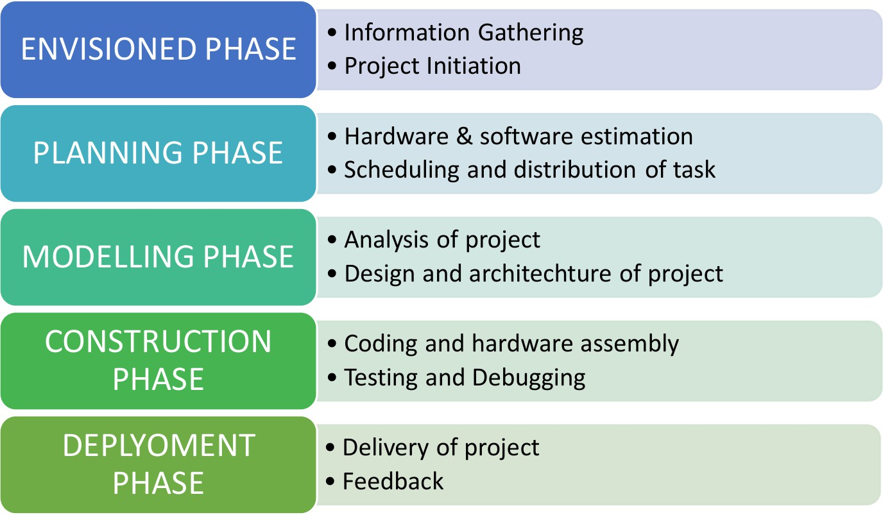

Figure 1. Model of phases in project management.

Overview and Benefits

The system uses WhatsApp, which needs no training or installation. It’s low-cost, open-source, and portable. Ideal for education, prototyping, or accessibility-focused projects.

Organization of the Report
The report includes chapters on background, theoretical aspects, hardware/software requirements, implementation, testing, and future scope.

Chapter 02: Background Review & Survey

Related Works
In recent years, home automation has emerged as one of the most widely explored applications of the Internet of Things (IoT). Various projects and research studies have contributed to the development of IoT-based automation systems using platforms like mobile apps, web servers, voice assistants, and messaging services. However, the use of WhatsApp as a medium for home automation is relatively novel.
Key related works include:

Mobile App-Based Automation: Projects using Blynk, MIT App Inventor, or Android Studio to control devices via custom apps. While powerful, these solutions often require installation and are platform dependent.
Web Dashboard Systems: Some systems use Flask or Django with a public IP to host a webpage for home control. This approach needs cloud hosting or port forwarding, which introduces security and setup challenges.
Voice Assistant Integration: Integration with Amazon Alexa or Google Assistant allows hands-free control, but it requires additional APIs and compatible hardware. These systems are often expensive and complex to set up.
WhatsApp-Based Automation: Few open-source projects and hobbyist
solutions have experimented with Twilio’s WhatsApp API for sending

commands. These typically control basic LEDs or relays but often lack feedback mechanisms, motor control, or error handling.
This project includes:

- Using Twilio’s WhatsApp API for a widely accessible, platform- independent interface.
- Controlling both an LED (light) and a DC motor (fan) via Raspberry Pi GPIO.
- Using Flask server + Ngrok for easy and secure webhook exposure without static IP.
This creates a cost-effective, easy-to-use, and scalable home automation solution that is ideal for basic control tasks such as switching a light or fan ON or OFF.

Chapter 03: Theoretical Aspects

Internet of Things (IoT)

IoT (Internet of Things) refers to a network of physical devices (also called "things") that are connected to the internet and can collect, send, and receive data. These devices can include anything from sensors, home appliances, and wearable tech to industrial machines and vehicles.
In this project, IoT is applied by integrating hardware components (Raspberry Pi, sensors, and actuators) with cloud-based services (Twilio API and WhatsApp). The Raspberry Pi acts as an IoT gateway, bridging communication between the user and connected devices. Commands sent over WhatsApp are processed by the Flask server, which then triggers GPIO operations on the Pi to turn devices ON or OFF.

Features of IoT
- Intelligence: IoT devices aren’t just connected—they’re smart. They can process data, make decisions on their own, and respond to situations without needing human input, allowing for smarter and more efficient systems.
- Connectivity: One of the core features of IoT is that everything is connected. Devices talk to each other and to cloud platforms in real time, sharing data and making systems more responsive and interactive.
- Dynamic Nature: IoT systems are flexible and responsive. They can quickly adapt to changes—whether it’s a shift in the environment

or a user’s command—by updating their actions, status, or settings in real time.
- Enormous Scale: IoT is built to handle huge networks. From smart homes to entire cities, it can connect billions of devices worldwide, making it a powerful technology for all kinds of industries.
- Sensing: Sensors are the eyes and ears of IoT. They gather data like temperature, motion, light, and humidity from the environment, helping devices make accurate and timely decisions.
- Heterogeneity: IoT includes diverse devices, protocols, and
platforms. Interoperability is essential to ensure that all components can communicate and function together.
- Security: With so many devices and so many data involved, security is a top priority in IoT. Strong authentication, encryption, and access controls are essential to keep data safe and prevent unauthorized access.

Advantages of IoT
- Communication: IoT makes it possible for devices to "talk" to each other and to centralized systems. This constant flow of information helps everything stay in sync, leading to faster, more coordinated decisions.
- Automation and Control: With IoT, many tasks happen automatically—no need for someone to step in every time. Devices can be programmed to act on their own, making systems more efficient and less dependent on manual control.
- Information: By collecting and analyzing data continuously, IoT
gives users a clearer picture of what’s happening—whether it’s

system performance, energy use, or environmental conditions— leading to smarter decisions.
- Monitoring: IoT makes it easy to keep an eye on things as they happen. Whether it’s tracking equipment, managing a space, or ensuring safety, it allows for up-to-the-minute updates and better control.
- Efficiency: Thanks to automation and smart use of data, IoT helps get more done with fewer resources. It reduces waste, cuts costs, and keeps everything running smoothly.

Disadvantages of IoT
- Compatibility: IoT brings together a mix of different devices, brands, and platforms. Getting them all to work smoothly with each other can be tricky and often requires extra effort to ensure everything connects and communicates properly.
- Complexity: Building and maintaining an IoT system isn’t always straightforward. It involves working with hardware, networks, and software—so it often needs people with the right technical know- how to set things up and keep them running.
- Privacy/Security: Because IoT devices are connected to the internet, they can be vulnerable to data leaks or cyberattacks. Protecting user data and keeping systems secure is a major concern that can’t be ignored.
- Safety: When something goes wrong in an IoT system—like a glitch or security issue—it can cause real problems, especially in sensitive areas like healthcare, factories, or smart homes. That’s why safety is just as important as functionality.

Application areas of IoT
- Smart Homes: IoT makes everyday living more convenient by automating things like lights, appliances, thermostats, and even home security. You can control everything from your phone or even set it to run automatically.
- Healthcare: Wearable devices and smart monitors help keep track of patients’ vital signs and medication times. They allow doctors to provide care remotely and can even send out alerts in case of emergencies.
- Agriculture: Farmers are using IoT to grow crops more efficiently. Sensors can monitor soil health, control irrigation, and check the condition of plants—making farming more precise and less wasteful.
- Industrial Automation: In factories, IoT helps keep machines running smoothly. It can predict when equipment needs maintenance, monitor performance, and manage production lines with minimal human involvement.
- Smart Cities: IoT plays a big role in making cities smarter—by managing traffic flow, improving waste collection, adjusting street lighting automatically, and keeping an eye on air quality and other environmental factors.

IOT Technologies and Protocols
- Wi-Fi (IEEE 802.11): The Raspberry Pi gets online using a wireless network—like a phone’s hotspot or home Wi-Fi—so it can send and receive messages or commands over the internet.

- HTTP Protocol: When a message comes in, the Flask app running on the Raspberry Pi listens for it using HTTP, a standard way for web services to talk to each other.
- Twilio WhatsApp API: This service makes it possible for the
Raspberry Pi to chat with you via WhatsApp. It receives the messages you send and delivers them to your device to act on.
- GPIO (General Purpose Input/Output): The Raspberry Pi has pins that can be programmed to control connected hardware—like turning lights on or running a motor.
- Ngrok: Since the Raspberry Pi usually runs on a private local network, Ngrok steps in to give it a public URL. This lets services like Twilio reach your Flask app even though it’s not hosted on a traditional web server.
- gpiozero Library: This Python tool helps control those GPIO pins
more easily. Instead of writing low-level code, you can use simple commands to interact with LEDs, motors, and other connected parts.

Project Layout

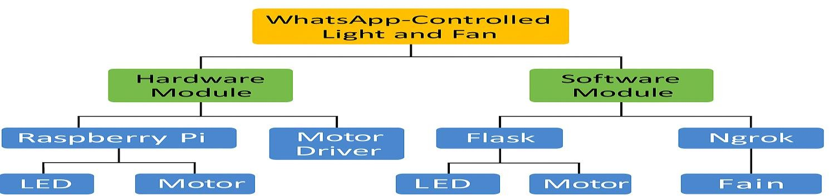

Figure 2. Layout of project module

    - Brief Description

The block diagram gives an overview of how the WhatsApp-Based Home Automation System works. It’s mainly organized into two key parts:
      - Software Part:
→ Python Code (whatsapp_bot.py): Handles GPIO control and command parsing.
→ Ngrok: Establishes a secure tunnel to expose the local Flask server to the public internet.
→ Twilio WhatsApp API: Acts as the interface between the user’s WhatsApp and the Flask server, delivering and receiving commands.
→ Flask Web Server: Runs a lightweight server on Raspberry Pi to listen for incoming HTTP POST requests from Twilio.

      - Hardware Part:
→ Raspberry Pi Zero 2 W: Acts as the central IoT controller.
→ L298N Motor Driver: Interfaces the Raspberry Pi with the DC motor (fan) to enable motor control.
→ LED & Resistor: Simulates a light device, connected to GPIO for switching ON/OFF.
→ 5V 2A Adapter: Powers the Raspberry Pi and motor driver.
→ Breadboard & Wires: Used for prototyping and electrical connections.

The structure or the figure above clearly illustrates the software and hardware components.

Chapter 04: Hardware Requirements

Raspberry Pi Zero 2W

Features:
    - Quad-core 1GHz CPU, 512MB RAM
    - Built-in Wi-Fi & Bluetooth
    - 40-pin GPIO header for hardware control
    - MicroSD, mini-HDMI, micro-USB OTG + power

Pin Configuration:
      - GPIO17 – LED (Light control)
      - GPIO18 – ENA (Motor enable)
      - GPIO22, GPIO23 – Motor control (IN1, IN2)
      - GND, 5V – Power & ground for components

  - LED
  - 5V DC Motor and Resistor
  - 5V 2A Adapter
  - Jumper Wires

  - 220-ohm resistor

  - L298N Motor Driver

Block diagram of the proposed system:

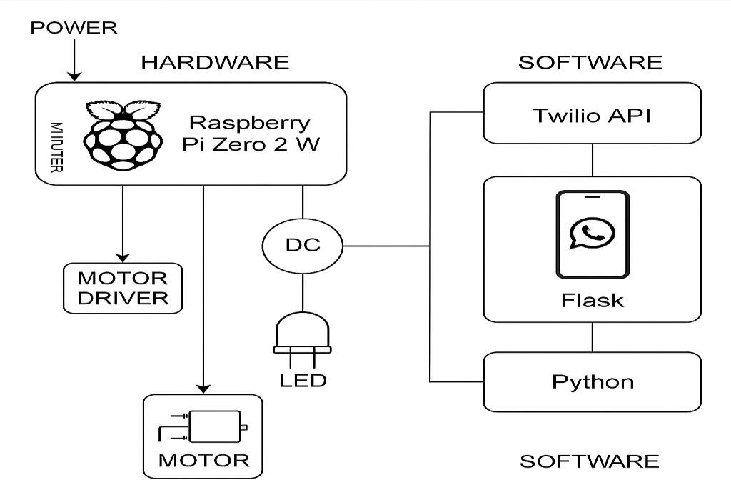

Working of the block diagram:

This system lets you control physical devices like a light or fan just by sending a WhatsApp message. It’s built using a Raspberry Pi and Twilio's Api:
      - Sending a Command: You simply send a message like "light on" or
"fan off" through WhatsApp.
      - Message Delivery: Twilio receives your message and passes it on to a Flask web server running on the Raspberry Pi.
      - Processing the Command: The Raspberry Pi runs a Python script that reads your message. Depending on what you wrote, it decides which device to turn on or off by changing the state of specific GPIO pins.

Controlling the Devices:
→ GPIO17 is used to control an LED light.

→ GPIO22, GPIO23, and ENA (GPIO18) are connected to an L298N motor drive, which powers a DC motor (used here as a fan).

Getting a Response:
Once your command is processed, you get a reply on WhatsApp like:
⬛ Light is ON
⬛ Fan is OFF

    - Circuit Diagram:
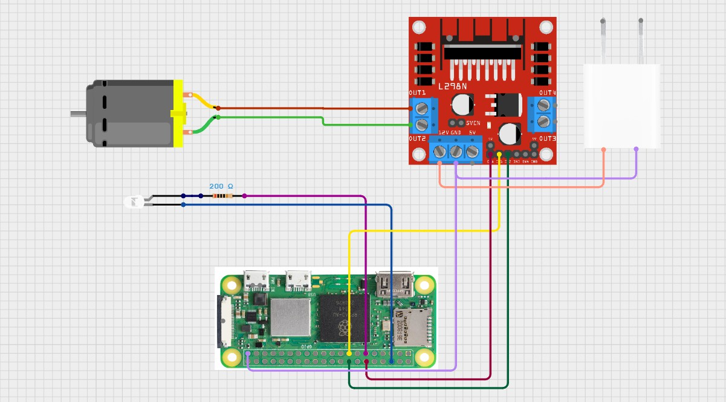

4.8.5 Components Required
Table 1. Component listing.

Sl. No. | Component and Specification | Quantity
1. | Raspberry Pi Zero 2W | 1
2. | DC Motor (5v) with Fan | 1

3. | L298N Motor Driver c | 1
4. | LED | 1
5. | Resistor (220 ohm) | 1
6. | 5V 2AMP Adapter with Female Power Connector | 1
7. | Jumper Wires | 6

Chapter 05: Software Requirements

The software requirements for the WhatsApp-Based Home Automation project are cantered around Python development and IoT integration using APIs and libraries compatible with the Raspberry Pi platform.

Operating System:
Raspberry Pi OS (Lite or Full) – A Debian-based Linux OS used to run the project on Raspberry Pi Zero 2 W.

Programming Language:

Python 3 – Main programming language used to control GPIO pins and create the WhatsApp automation bot.

Required Software and tools:

    - Python3: Core programming for automation and gpio interaction
    - Flask: Web server framework, usually it is used for backend work.
    - Twilio’s APi: To connect to WhatsApp sandbox and receive or send
message through WhatsApp.
    - pip: Python manage packager to install libraries.
    - Ngrok: Used to expose the flask server using a public URL.
    - Gpiozero library: Python libraries to control raspberry Pi gpio pins.

Setup and Configuration Summary:
    - Flask server is created using Python on the Raspberry Pi.
    - Twilio is configured with a webhook pointing to the Ngrok URL.

    - GPIO pins are mapped in Python code using gpiozero to control LED and motor.
    - The Pi must be connected to the internet via Wi-Fi or hotspot for full functionality.
This software parts ensure to run the WhatsApp home automation project efficiently.

Chapter 06: Project development & Testing Aspects

: The project was developed by the following stages

→ Component Collection & Assembly:
    - All the necessary hardware—Raspberry Pi, L298N motor driver, LED, DC motor, and a power supply—was collected and set up on a breadboard for easy connections.

→ Environment Setup:
    - The Raspberry Pi OS was installed on a 32GB microSD card. Essential software like Python, Flask, Twilio’s Python library, and gpiozero (for controlling GPIOpins) was installed using pip.

Code Development:

      - A Flask server was built to handle incoming messages from WhatsApp.

      - The gpiozero library was used to control the GPIO pins on the Raspberry Pi.
      - Python code was written to detect and respond to commands like

"light on/off" and "fan on/off".

    - Ngrok & Twilio Configuration:

      - Ngrok was set up to create a secure tunnel to the Flask server, making it accessible from the internet.
      - Then, Twilio’s WhatsApp Sandbox was configured to forward messages to the Ngrok-generated URL

Integration Testing:

      - The full setup was tested by sending messages via WhatsApp. Each message triggered the correct GPIO response, confirmed by observing the LED and motor turning on or off accordingly.

Testing Outcomes:

    - LED Test: Successful ON/OFF switching using WhatsApp
messages “light on” and “light off.”
    - Motor Test: DC fan turned ON and OFF correctly using “fan on” and “fan off.”
    - Twilio Webhook: Proper message delivery and acknowledgment.
    - Power Supply Test: Stable operation observed with a 5V 2A adapter.

Issues Faced & Solutions:

Issue Faced: | Solution:
- Motor vibrating but not  rotating | - Used external 5V 2A adapter  for sufficient current
- Twilio not responding | - Fixed webhook and verified  Twilio sandbox setup
- ENA pin not working  - Gpio busy error | - Soldered the ENA connection securely to  GPIO18

Chapter 07: Conclusion & Future Scope

→ 7.1 Result: The project successfully created a WhatsApp-controlled home automation system, allowing users to turn an LED (light) and a DC motor (fan) on or off using simple text commands like "light on" or "fan off." The Raspberry Pi accurately interpreted these messages, controlled the appropriate GPIO pins in real time, and sent instant acknowledgment responses back to the user through Twilio’s WhatsApp API, making the interaction smooth, responsive, and user- friendly.
→ 7.2 Conclusions: This project exemplifies an elegant and cost-effective approach to remote home automation powered by IoT technology. Seamlessly integrating widely used platforms like WhatsApp and Python, it delivers an intuitive and highly accessible interface for managing everyday appliances. Moreover, its modular architecture ensures exceptional scalability and flexibility, paving the way for

sophisticated and customizable automation solutions tailored to evolving user needs.

7.3 Limitations:

- Dependent on stable internet connectivity for both the Raspberry Pi and mobile device.

- Twilio’s free sandbox plan may have message limitations or delays.

- Limited to only two devices (light and fan) in the current implementation.

- Security mechanisms like user authentication are not included.

→ 7.4 Further Enhancement and Future Scope: Future enhancements could transform this system into a comprehensive smart home hub by enabling control over multiple devices such as smart plugs, bulbs, and various sensors. Incorporating sensor-driven automation—like motion detection and temperature monitoring— would add intelligent, context-aware functionality. Developing a bespoke mobile or web dashboard would provide users with a sleek, intuitive interface for effortless management. To bolster

security and oversight, integrating user authentication and detailed activity logging is essential. Finally, upgrading from Twilio’s sandbox to the full production API will ensure robust, scalable performance suitable for real-world deployment.

References

Twilio's Documentation: https://www.twilio.com/docs
- Raspberry Pi Official Website – https://www.raspberrypi.com/
- Ngrok Documentation – https://ngrok.com/docs
- L298N Motor Driver Datasheet – https://components101.com/motor-driver/l298n-motor-driver- module
- Raspberry Pi GPIO Pinout – https://pinout.xyz/
- Flask Documentation: https://flask.palletsprojects.com/en/lates
- https://search.app/qzKmjbtUBauCtHC46
- https://youtu.be/2bganVdLg5Q?feature=shared
- https://circuitdigest.com/tutorial
- Used Blynk for Circuit design and Logic Diagram

Appendix 01

A01.1. Code Listing:
This project is driven by a Python script that processes incoming WhatsApp messages and manages the Raspberry Pi’s GPIO pins accordingly. In this appendix, you’ll find the complete source code along with detailed explanations of each part.

A01.2. Main Code:
from flask import Flask, request

from twilio.twiml.messaging_response import MessagingResponse
import RPi.GPIO as GPIO

from signal import signal, SIGINT from sys import exit
app = Flask(name) #Gpio Setup LED_PIN = 17
IN1 = 22

IN2 = 23

ENA = 18

GPIO.setmode(GPIO.BCM) GPIO.setwarnings(False) GPIO.setup(LED_PIN, GPIO.OUT) GPIO.setup(IN1, GPIO.OUT) GPIO.setup(IN2, GPIO.OUT) GPIO.setup(ENA, GPIO.OUT)
GPIO.output(ENA, GPIO.HIGH) # Keep ENA high to enable motor def cleanup_gpio(signal_received=None, frame=None):
print("\nCleaning up GPIOs...") GPIO.output(LED_PIN, GPIO.LOW) GPIO.output(IN1, GPIO.LOW) GPIO.output(IN2, GPIO.LOW) GPIO.output(ENA, GPIO.LOW)
GPIO.cleanup() exit(0)
signal(SIGINT, cleanup_gpio) @app.route("/bot", methods=["POST"])

def bot():

msg = request.values.get('Body', '').lower() resp = MessagingResponse()
if 'light on' in msg: GPIO.output(LED_PIN, GPIO.HIGH)
resp.message("⬛ Light is ON") elif 'light off' in msg:
GPIO.output(LED_PIN, GPIO.LOW)
resp.message("⬛ Light is OFF") elif 'fan on' in msg:
GPIO.output(IN1, GPIO.HIGH) GPIO.output(IN2, GPIO.LOW)
resp.message("⬛ Fan is ON") elif 'fan off' in msg:
GPIO.output(IN1, GPIO.LOW) GPIO.output(IN2, GPIO.LOW)
resp.message("⬛ Fan is OFF") else:
resp.message("Send:\nlight on / light off\nfan on / fan off") return str(resp)

if name == "main":

app.run(debug=True, port=5000, host="0.0.0.0")

A01.3. Libraries:

- Flask – Lightweight Python web framework for handling webhook requests
- Twilio – Interface for sending and receiving WhatsApp messages
- gpiozero – Simplified control of Raspberry Pi GPIO pins
- request – Retrieves form data from POST requests
- twilio.twiml.messaging_response – Generates WhatsApp- compatible reply to messages
- os / pip / system utilities – Manage environment setup and package installation
#All the libraries were installed using pip command

Appendix 02

A02.1. Project Proposal Form

The project proposal form was prepared and duly signed from our faculty-in-Charge Dr. Biswa Ranjan Swain. The same is attached at the last of this report.

A02.2. Project Management

# | Component | Individual Contributions in % |  |  | Total
 |  | Dhruv Mohapatr a (Group  Leader) | Akash Kumar Panda | Ansuman Sahu | Contribution
1. | Planning | 45% | 40% | 15% | 100%
2. | Background  Research and Analysis | 45% | 40% | 15% | 100%
3. | Hardware design | 70% | 20% | 10% | 100%
4. | Software design | 70% | 20% | 10% | 100%
5. | Testing | 50% | 30% | 20% | 100%
6. | Final Assembling | 33.33% | 33.33% | 33.33% | 100%
7. | Project report  writing | 50% | 25% | 25% | 100%
8. | Presentation | 10% | 40% | 40% | 100%

9. | Logistics | 40% | 30% | 30% | 100%

A02.3. Bill of Material:
Table 1. Component listing.

# | Component | Specification | Unit  Cost | Quantity | Total
1. | Raspberry pi | zero 2w | 1649 | 1 | 1649
2. | power supply adapter – branded | 5V 3 Amp | 550 | 1 | 550
3. | Raspberry pi  micro-SD | 32 GB | 489 | 1 | 489
4. | DC motor | 5V | 20 | 1 | 20
5. | Motor  Driver | L298N | 120 | 1 | 120
6. | Jumper wires | - Male to female  - Female to Female | 60 | 30 | 60
7. | Relay  Module | 5V 1ch 10A | 59 | 1 | 59

8. | Adaptor with F  connector | 5V 2A | 299 | 1 | 299
Grand Total |  |  |  |  | 3306

Appendix 03
This section outlines the key hardware components used in the project along with their technical specifications and reference links for further details.

A03.1. Data Sheets:

Raspberry Pi Zero 2 W: A compact controller board with quad-core ARM Cortex-A53, 512MB RAM, Wi-Fi, and 40 GPIO pins. Product Page: http://www.raspberrypi.com/products/raspberry-pi- zero-2-w/
Datasheet: http://datasheets.raspberrypi.com/rpizero2/raspberry-pi- zero-2-w-product-brief.pd

L298N Motor Driver Module: Dual H-Bridge motor driver supporting 5V–35V with built-in heat sink and power LED. Reference: http://components101.com/motor-driver/l298n-motor- driver-module
Datasheet: http://www.st.com/resource/en/datasheet/l298.pdf

5V DC Motor: A general-purpose motor used for fan simulation, typically rated for 5V–9V and 100–300 RPM

LED with 220Ω Resistor: Standard 5mm LED paired with a 220Ω resistor
to safely demonstrate ON/OFF states.

32GB Class 10 MicroSD Card: Used to load Raspberry Pi OS and store all necessary code and project files, offering fast read/write speed.

